- Open powershell in the directory path
- Before doing anything in Terraform, first login or check if you are logged in:
aws sts get-caller-identity
- Type ‘AWS configure’ and supply the
requested values that is obtained in AWS:
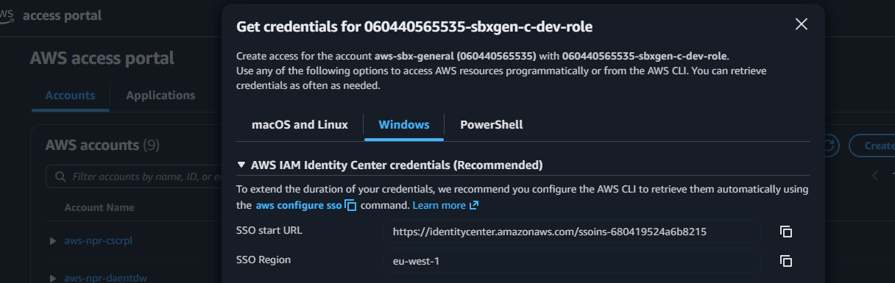
- Type ‘Terraform init’ and enter in the ps shell and wait for Terraform to confirm that is has ‘Terraform has been successfully initialized!’
- Have Terraform check if the secrets exist, so that if it does not it should create it otherwise ignore it
Type ‘terraform import aws_secretsmanager_secret.fraud_poc_secrets fraud_poc_secrets’
- Type ‘Terraform plan’ and see that there is plan generated
- Now Type 'Terraform apply’ to create the role and policies
- When prompted to type ‘yes’ if the actions must be performed, type ‘yes’
- You should get ‘Apply complete! Resources: 1 added, 0 changed, 0 destroyed.’
- Open AWS and login into ‘060440565535-sbxgen-c-dev-role’
- Go to IAM -> Roles and search for ‘fraud’ -> if successful you should see an AWS Role called ‘fraud-poc-aws-role’ with policies attached
- You should also see in the AWS Secrets Manager -> ‘af-south-1’ region a secret called ‘fraud_poc_secrets’ that contains the necessary secrets for the PostgreSQL and Kafka

